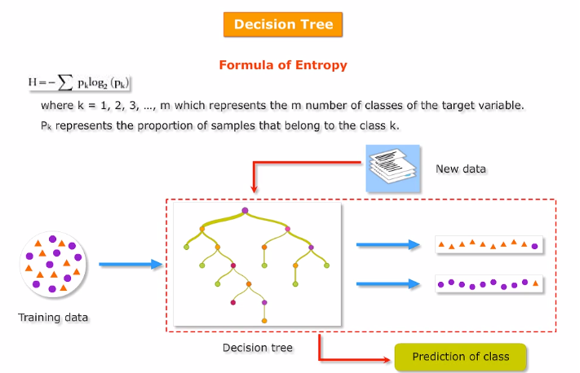

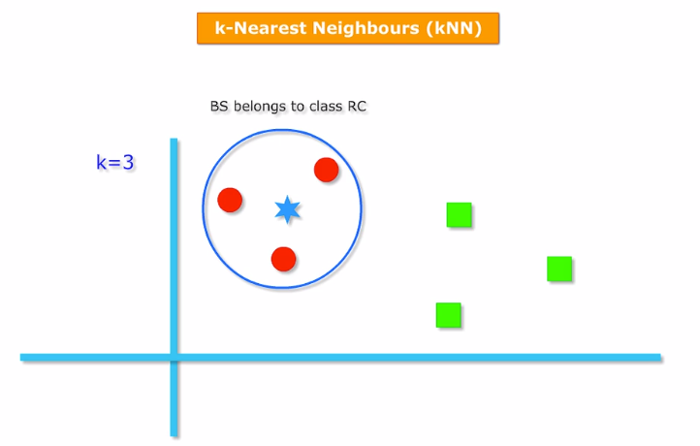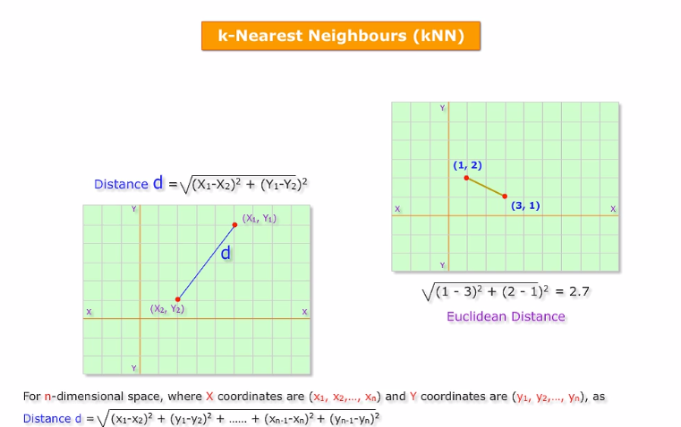

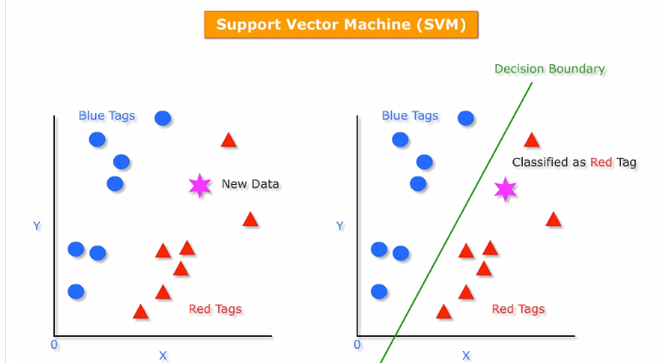

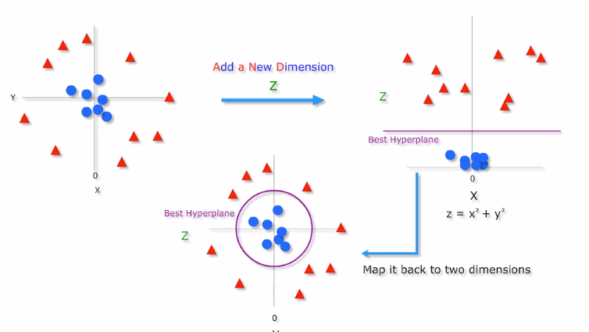

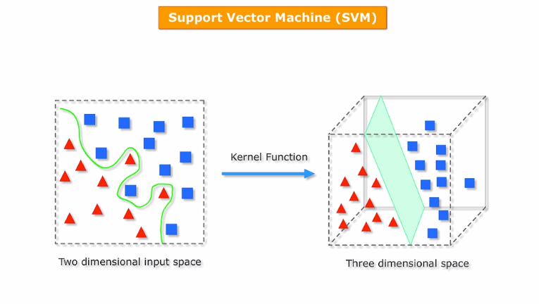

***Regression***

*These are of 2 types regressions :*

1. ***Linear reg****. :- in this outcome is a no and a cont variable*
2. ***Logistic reg.***

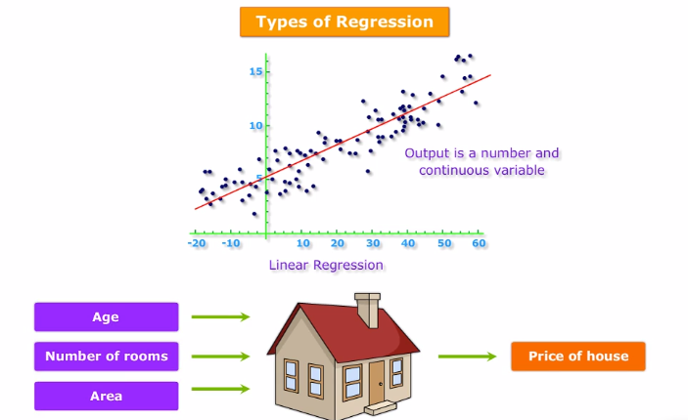

*Linear regression helps in finding out the predicted price of the house given its age no of rooms and area.*

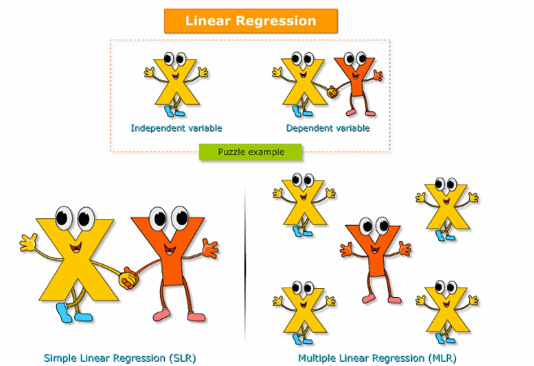

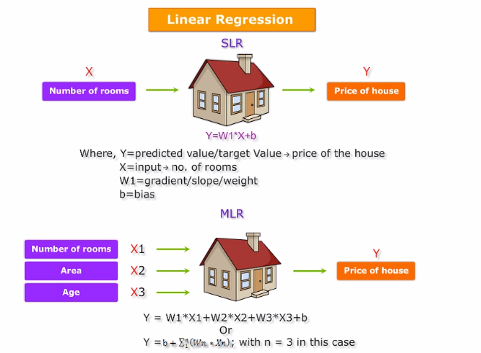

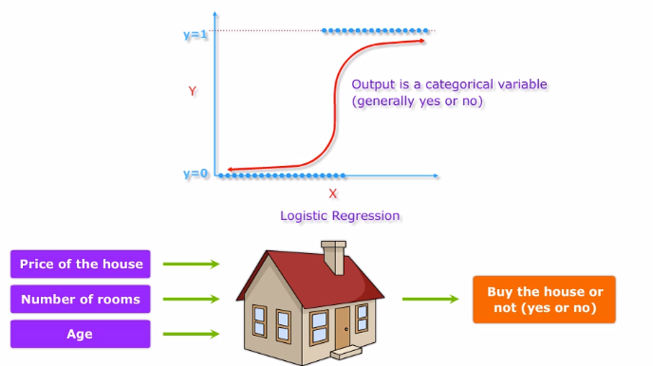

*Logical regression is actually a classification technique , it is name regression bcoz the technique is too similar too linear regression .*

***ENSEMBLE***

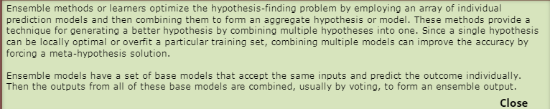

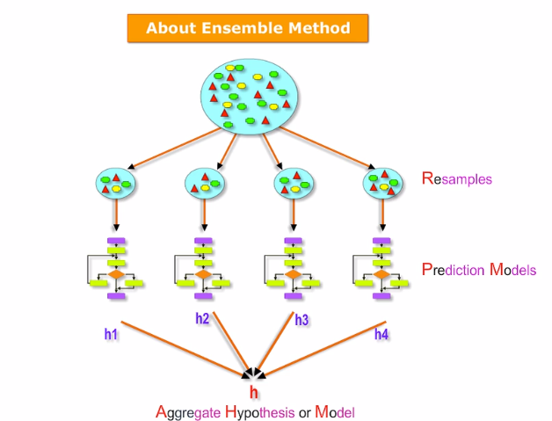

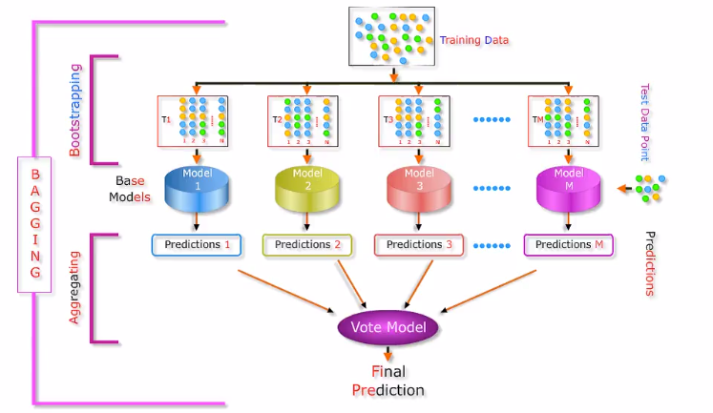

*Random forest comes in this type.*